7. Generator Classes in Hibernate (AUTO, IDENTITY, SEQUENCE)

Hibernate ID Generator Classes
Hibernate uses ID Generator strategies to automatically generate primary keys for entity classes.
Commonly used strategies:
- AUTO
- IDENTITY
- SEQUENCE

GenerationType.AUTO
- Hibernate automatically chooses the best strategy based on the database.
- For:
  - MySQL → uses IDENTITY
  - Oracle / PostgreSQL → uses SEQUENCE

When to use : When you don’t want to worry about DB-specific behavior.
Example:
@Id
@GeneratedValue(strategy = GenerationType.AUTO)
private int id;

GenerationType.IDENTITY (Most common with MySQL)
- Uses database auto-increment column.
- Default value starts from 1.
- DB generates ID at insert time.

Best for MySQL, SQL Server.
- Simple and widely used.

Example:
@Id
@GeneratedValue(strategy = GenerationType.IDENTITY)
private int id;

3.GenerationType.SEQUENCE (Best for Oracle/PostgreSQL)
- Uses a database sequence object.
- Hibernate gets ID before insert.

SEQUENCE starts at 1, but if Hibernate restarts can cause ID gaps (1, 51, 101…) due to default allocationSize = 50.

Best for Oracle, PostgreSQL
- Better performance than IDENTITY

Example:
@Id
@GeneratedValue(strategy = GenerationType.SEQUENCE, generator =
"student_seq")
@SequenceGenerator(
name = "student_seq",
sequenceName = "student_sequence",
allocationSize = 1
)
private int id;

allocationSize (Important)

allocationSize = 1
- 1 → Hibernate fetches one ID at a time
- 50 (default) → Hibernate fetches 50 IDs in one DB call (better performance)

Comparison Table
Strategy | DB Support | How ID is Generated | Default Start Value | Allocation / Increment Details | Performance
AUTO | All DBs | Hibernate chooses best strategy based on DB | 1 |  | Good
IDENTITY | MySQL, SQL Server | Database AUTO_INCREMENT | 1 | No allocation. ID generated after INSERT. Increment controlled by DB | Medium
SEQUENCE | Oracle, PostgreSQL | Database SEQUENCE | 1 | DB INCREMENT BY 1, Hibernate allocationSize = 50 (default) | Best

IDENTITY vs SEQUENCE — Execution Flow Diagram
IDENTITY Generator (MySQL)
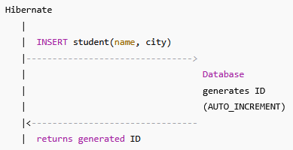

What happens internally
- Hibernate sends INSERT
- Database generates ID
- Hibernate fetches ID after insert
📌 Hibernate does not know ID beforehand
SEQUENCE Generator (Oracle / PostgreSQL)
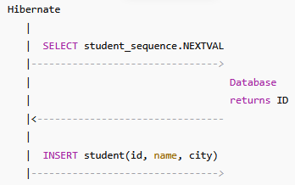

What happens internally
- Hibernate fetches ID before insert
- Hibernate inserts record with ID
📌 Hibernate knows ID beforehand

AllocationSize vs IncrementBy

Property | Who controls | Meaning
allocationSize | Hibernate | How many IDs reserved in memory
incrementBy | Database | How sequence increments

Batch Insert Example (Why IDENTITY fails)

Try inserting 3 students

SEQUENCE (works)

for (int i = 1; i <= 3; i++) {
session.save(new Student("S" + i, "Hyd"));
}
Hibernate SQL:
SELECT NEXTVAL FROM student_sequence; -- 1
SELECT NEXTVAL FROM student_sequence; -- 2
SELECT NEXTVAL FROM student_sequence; -- 3

INSERT INTO student VALUES (1, ...);
INSERT INTO student VALUES (2, ...);
INSERT INTO student VALUES (3, ...);

✔ Can batch inserts
✔ Faster

IDENTITY (cannot batch)

INSERT INTO student VALUES (...); -- wait for ID
INSERT INTO student VALUES (...); -- wait for ID
INSERT INTO student VALUES (...); -- wait for ID
❌ One-by-one insert
❌ Slower
=======================================================

